User Manual

Table of Contents

Design and Development Team 2

About This Software Package 2

Register 3

Registration Errors 3

Password Validation 3

Unique Username 3

Email Validation 4

Passwords Do Not Match 4

OAuth 4

Log In 5

Login Errors 5

Incorrect Username or Password 5

No details Entered 5

Manage Account 6

Manage Account Errors 6

Incorrect Current Password 6

Forms 7

View All 7

Create 8

Edit 9

Delete 9

Submit 10

Fill 10

Form Data 11

Statistics 12

Export 12

Mobile Views 13

Login 13

ListTable 14

FillTable 15

Statistics 16

Form Data 17

Create Form 17

User Manual

**Design and Development Team**

*Shane Murphy: X00085315*

*System Design, Software and Database Development, System Testing & Quality Control.*

*Maciej Macierzynski: X00086366*

*System Design, Software and Database Development, System Testing & Quality Control.*

**About This Software Package**

This project aims to provide a simple, eloquent solution to sign up events data collection bottlenecks. Inspiration for this project came from first hand experience with college society and job fair sign up processes where applicants are predominantly required to sign up using pen and paper.

By making a service available to these organizations and societies, whereby they can create their own customizable e-forms to capture data specific to that organizations needs, store it and export it later, we can reduce time spent capturing data and processing paper forms into a database or email client later.

**Register**

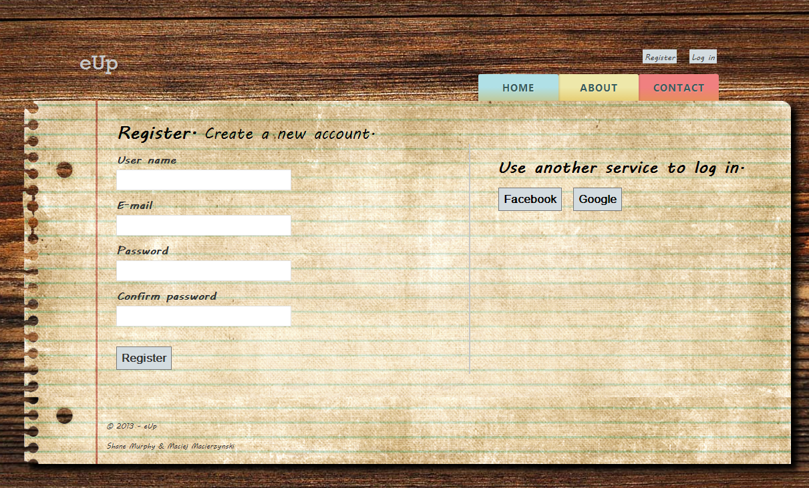

Users are required to provide a unique username, valid E-mail address and password when registering for the eUp service. Usernames must not already be in use by another user, Passwords must have at least 1 capital letter, a number or special character and be at least 7 letters long, and no longer than 16 characters. Passwords are to be entered twice to ensure no typing errors occur.

These conditions are validated and checked by the application, the following error messages are displayed to the user where appropriate.

**Registration Errors**

**Password Validation**



**Unique Username**



**Email Validation**



**Passwords Do Not Match**

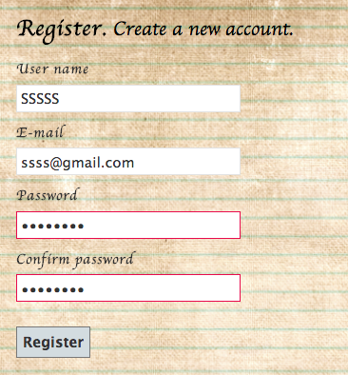

**OAuth**

Users may choose to forego creating an account and create an account via their preferred social networking site. The user must grant access to their basic data in order to proceed with this login method. Once appropriate permissions are received, the user must choose a username to associate themself with in the eUp application.



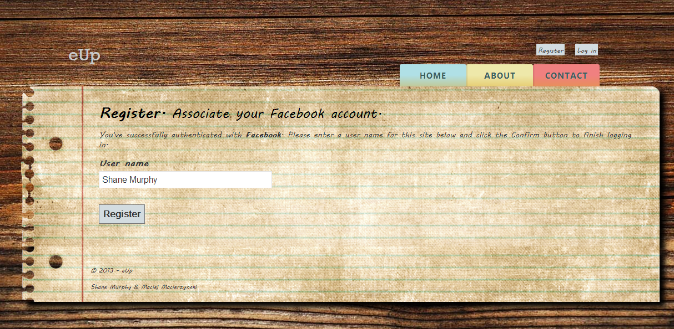

**Log In**

The user is required to enter their existing username and associated password in order to gain access to their user account and forms. A user will not be able to log in without first having registered. The user is validated and granted access to their account or one of the following errors is displayed to the user.

**Login Errors**

Incorrect Username or Password

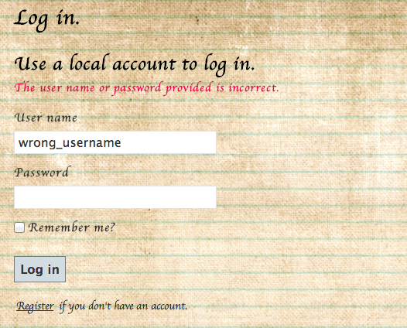

No details Entered

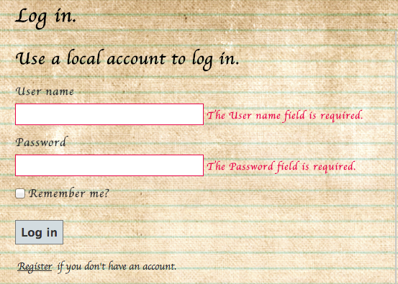

**Manage Account**

Once a user has logged in, they may manage their account by click on their username at the top right hand corner of the screen. A page will be displayed allowing users to change their password and connect to their login to their social media accounts.

The user may not change their password without first entering the correct current password.

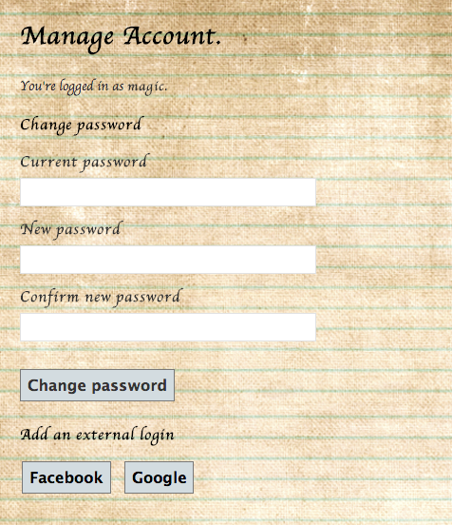

**Manage Account Errors**

**Incorrect Current Password**



**Forms**

**View All**

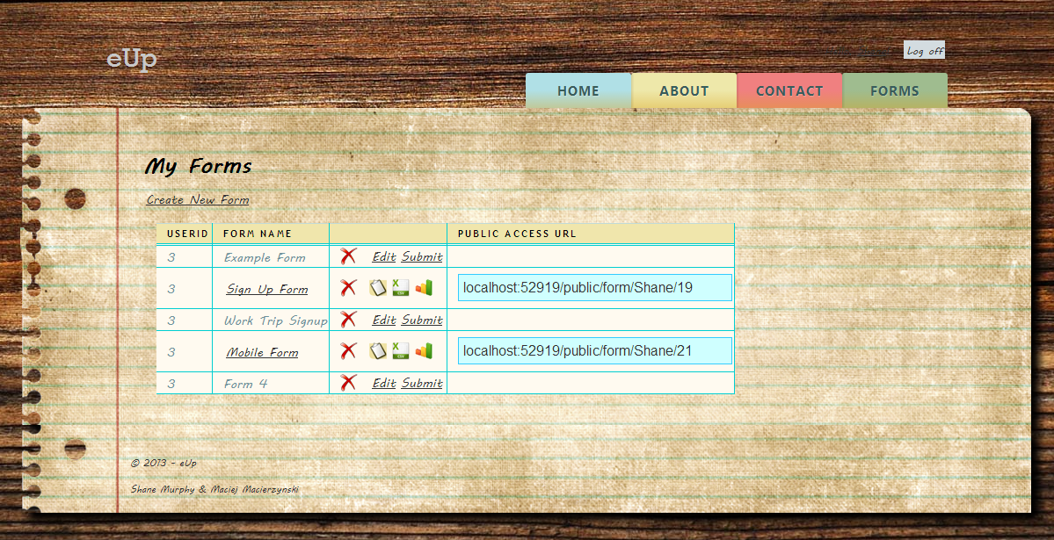

Clicking the Forms tab on the page brings the user directly to an overview of their current forms associated with their account. From here the user can choose to Delete, Edit or Submit any forms that haven’t been submitted already, or Delete, Submit, Export or view statistics of any submitted forms. All submitted forms have a public URL that can be used to directly access the Fill Form page for each individual form. Users may also choose to create a new form.

**Create**

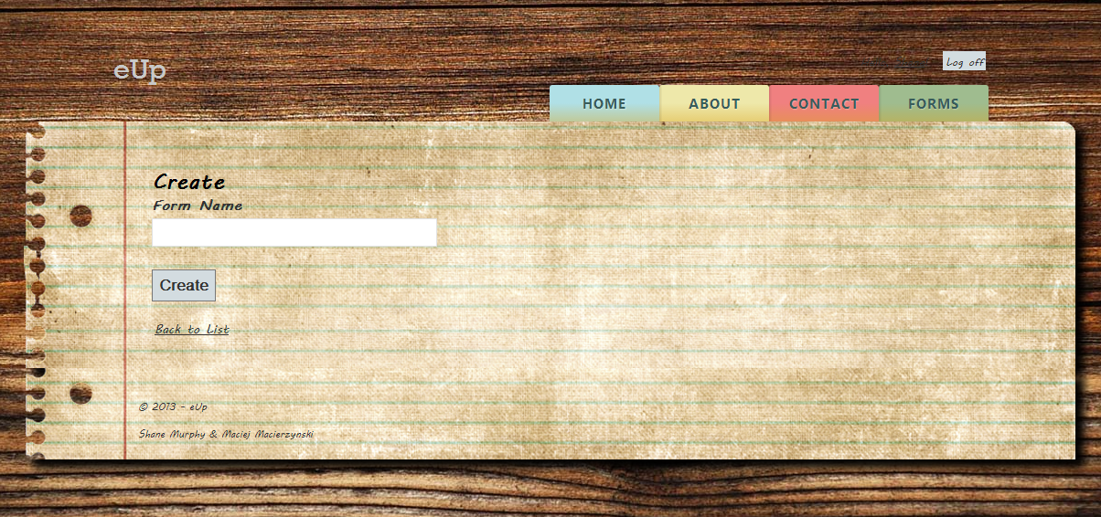

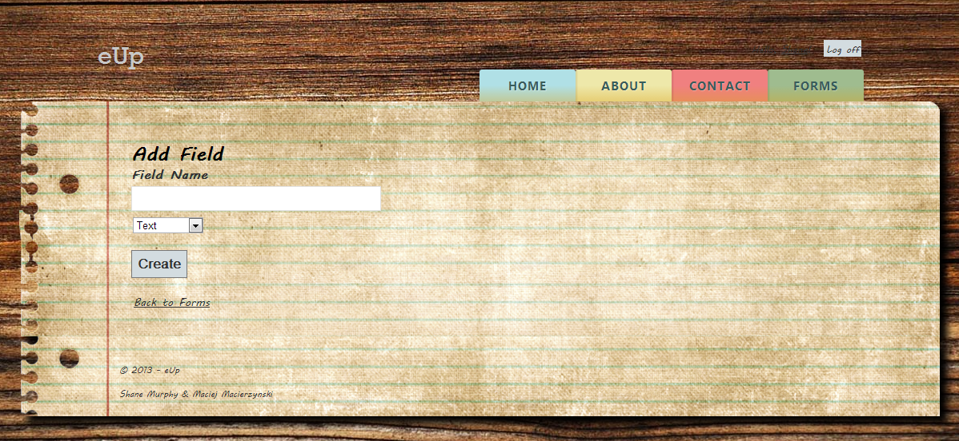

To create a form a user must specify a form name; once this has been supplied the user will be asked to name their form fields, which will later be submitted as column names in their custom table. As the user enters each field name, they are requested to select whether each field is one of 3 types, Text, Numeric or Boolean. This selection aids in input validation when data is being entered into he form and also allows for statistics to be generated from this input.

**Edit**

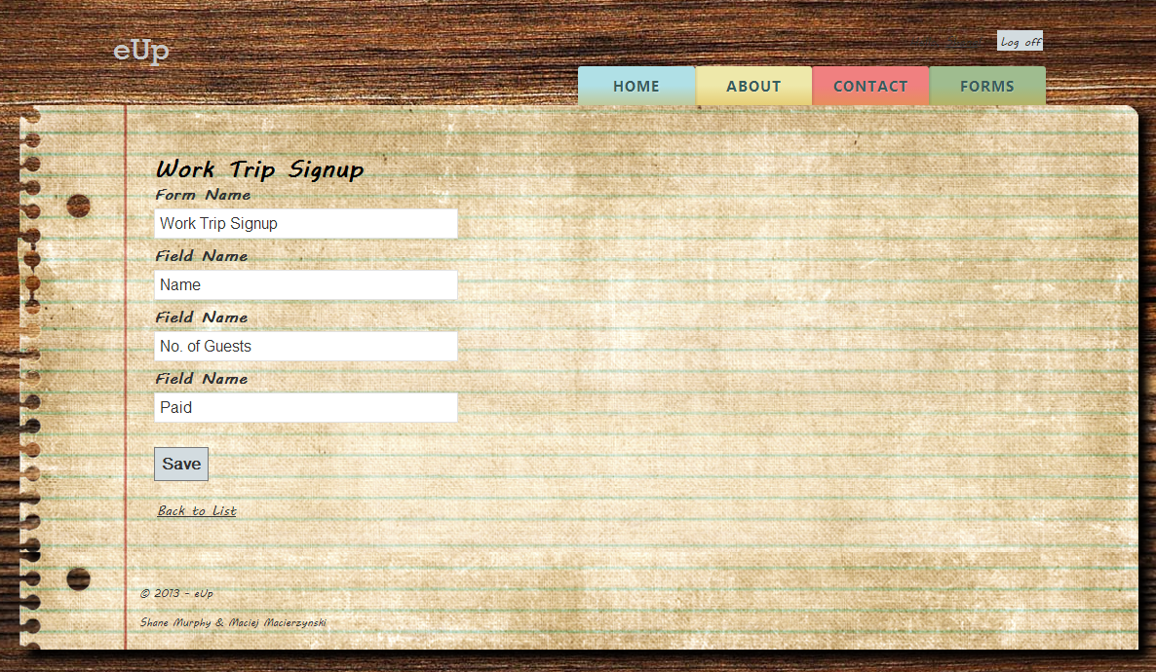

The Edit option allows users to edit the details of their already created, but unsubmitted forms. This includes changing the Form name, and all Field names within the form.

**Delete **

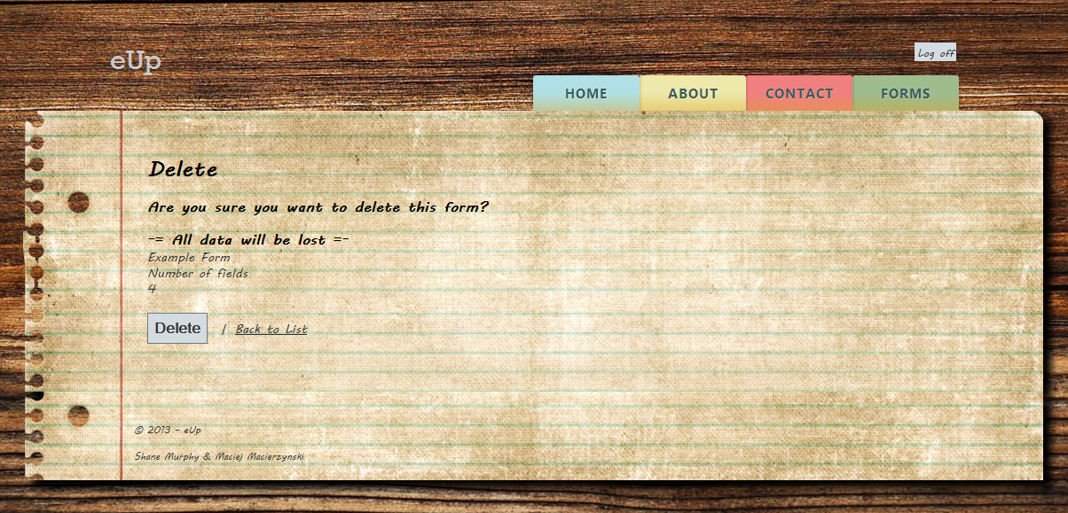

Any form, whether it is submitted to the SQL database or not can be deleted. This is a permanent action that cannot be recovered from; the user is warned of this and asked to confirm the request to delete the table. If the table has been submitted and data entered into the table, all data will be lost upon deletion. It is recommended the table be exported before deleting permanently.

**Submit**

The form must be submitted to the system before any data can be captured. By submitting the form, you lose the ability to edit the form in any way. Once submitted, the options to edit or submit are replaced with icons allowing you to enter data into the table, export as CSV or view statistics relating to the table, if data exists in the table.

**Fill **

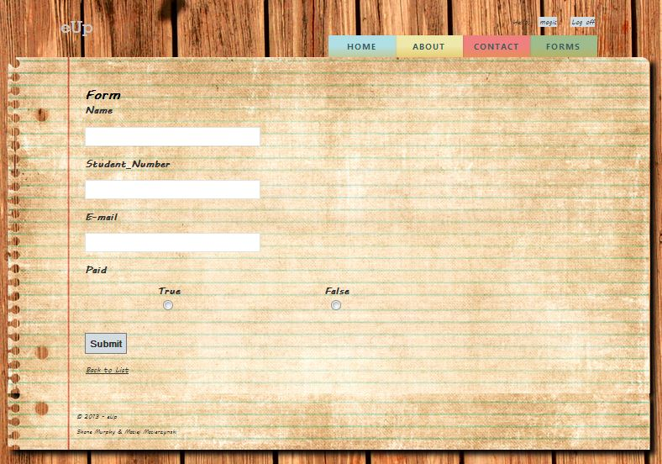

Each form is presented differently to the user when the Fill view is called. It displays each form field in the order they were submitted to the system. The field type selected earlier is used here to validate user input, depending on the field type. Boolean types are displayed as two radio buttons.

***Text Validation***



***Numeric Validation***

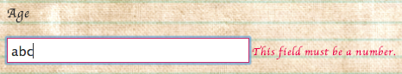

**Form Data**

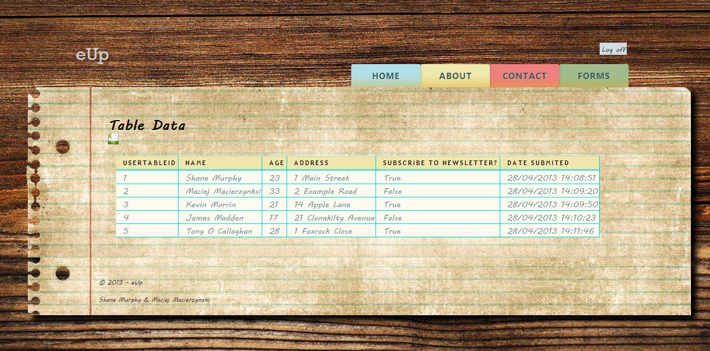

By clicking the required form name, the user may manually view all data submitted to the form to date. The user may also export the form as a CSV file directly from this page.

**Statistics **

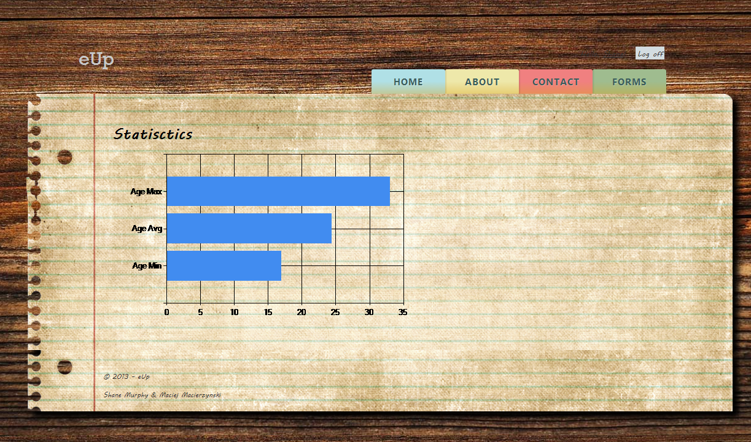

Statistics are generated for all numeric and Boolean form fields in a table. This data is real-time and can be accessed as long as there is values stored in the form.

**Export **

By clicking on the CSV icon beside the form name, or within the table data view, the user can download a .csv file of the table to their local machine.

**Mobile Views**

All major functionality is available from mobile devices in a more mobile friendly layout. All functionality works as specified for the main view unless otherwise specified.

**Login**

Users can login to the service from a mobile device just as they would from a full desktop web browser.

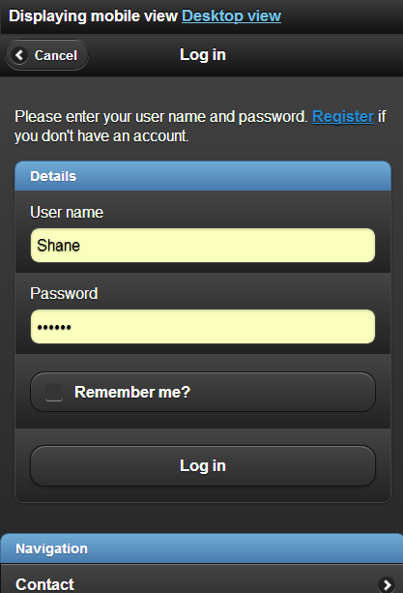

**ListTable**

Once Logged in, users will have access to their associated forms. They may access the form data by clicking the form name or larger square of the select button, or view statistics by clicking the word ‘Statistics’. Clicking the arrow to the right will bring the user to a mobile view where they can collect form data.

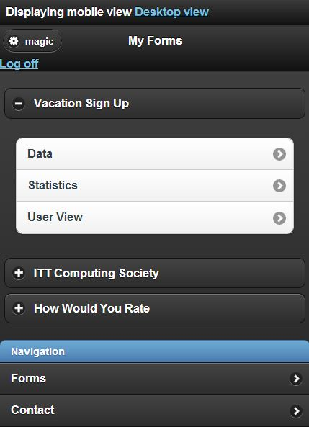

**FillTable**

Users can fill the table with data from a mobile view.

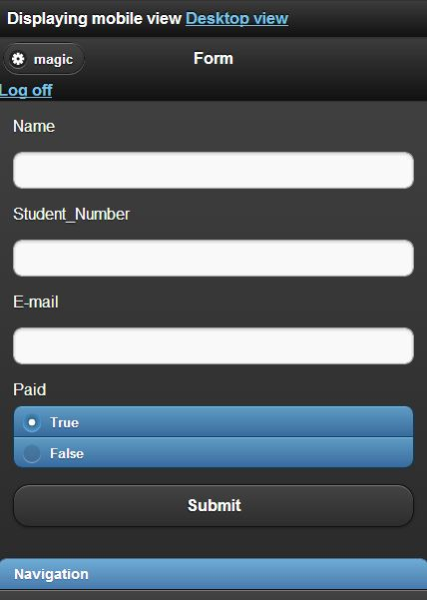

**Statistics**

Users can view real-time statistics from their mobile device.

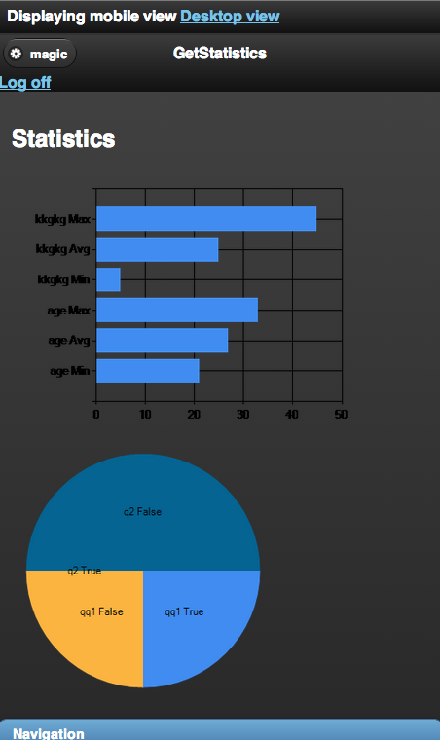

**Form Data**

Users can view all form data currently in the table from their mobile device.

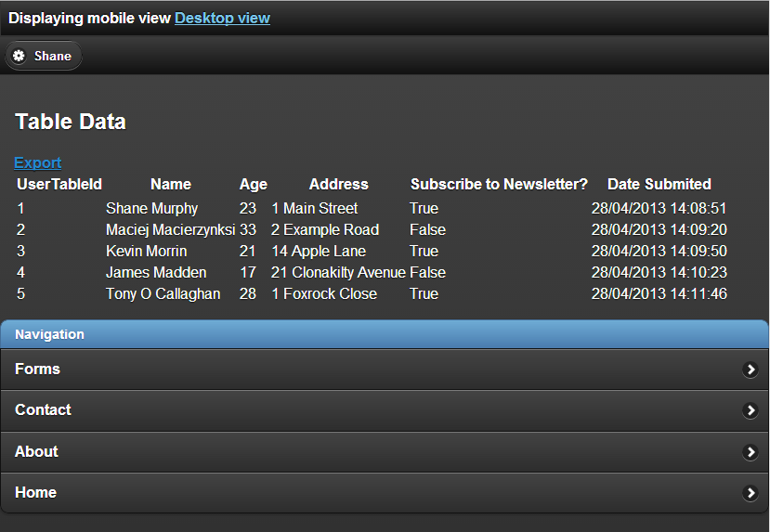

**Create Form**

Users may not create a new form from a mobile device; this must be done in a full desktop browser. The option to switch to a desktop view is available in the event that this functionality is required away from a desktop machine.